1. Flash jp461 image onto the sd card.
2. Connect jetbot with keyboard, mouse and monitor. After doing the initial setup, open the terminal and run the following

$ sudo apt-get update

$ git clone <https://github.com/hailoclu/jetbot.git>

$ cd jetbot

$ ./scripts/configure_jetson.sh

1. Open configure.sh file in /jetbot/docker in VIM and override the l4t version.

export L4T_VERSION=”32.6.1”

Add the below lines before else

elif [[ “$L4T_VERSION” == “32.6.1” ]]

then

JETBOT_BASE_IMAGE=nvcr.io/nvidia/l4t-pytorch:r32.6.1-pth1.9-py3

Make these changes, save and close

1. Now open the terminal and run the below:

$ cd docker

$ source configure.sh

$ ./set_nvidia_runtime.sh

$ export JETBOT_JUPYTER_MEMORY=500m

$ export JETBOT_JUPYTER_MEMORY_SWAP=3G

1. Run the below commands and if you do not get an error then move to step 12 or else continue next step

$ sudo systemctl enable docker

$ ./enable.sh $HOME

1. $ ./build.sh – it will throw an error as shown below:

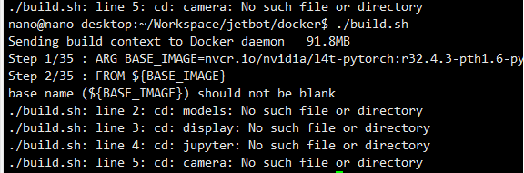

$ cd base

$ sudo docker build \

--build-arg BASE_IMAGE=nvcr.io/nvidia/l4t-pytorch:r32.6.1-pth1.9-py3 \

-t $JETBOT_DOCKER_REMOTE/jetbot:base-$JETBOT_VERSION-$L4T_VERSION \

-f Dockerfile \

../..

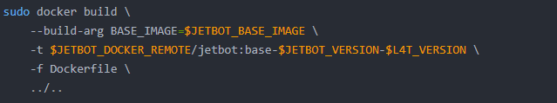

It took me 1-2 hours for this step to complete without any error.

1. Go to docker folder and open build.sh in VIM and comment the first line as shown below:

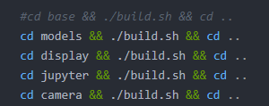

1. In the terminal run the following:

$ ./build.sh

1. Now try to view the images built in the jetbot using

$ docker images

1. If you get an authentication error, then run the following:

$ sudo chmod 666 //var/run/docker.sock

1. Now you will be able to view the images as below:
2. $ ./enable.sh $HOME

You can see the light on jetson with IP. Open the jetbot IP in the browser.

Remove the connections to mouse, keyboard and monitor.

1. In the IP, Install stable-baselines by pressing the plus (+) key in the Jupyter notebook to launch a terminal window and run the following two commands:

apt install python3-scipy python3-pandas python3-matplotlib

python3 -m pip install stable_baselines3==0.8.0

1. Go to the jetbot/notebooks/isaacsim_RL folder and upload the pretrained model from the below link:

<https://drive.google.com/file/d/1skqmsRawVQakp16J10B6P8r2UdaSLZ_D/view?usp=sharing>

1. Run the jupyter notebook: isaacsim_deploying.ipynb